April 24, 2007

Hello Adventist Friend*:

The following graphic illustrates a controversy that you are involved in howbeit, perhaps unwittingly. Our intention in contacting you is strictly for your education and edification. Are you sufficiently equipped to make an intelligent decision respecting your destiny and earthly dealings just prior to Christ’s soon coming?

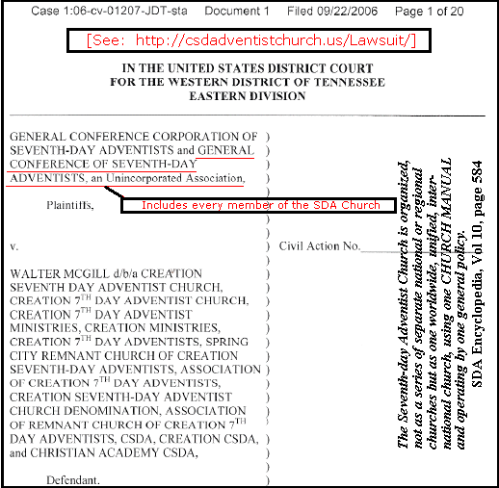

Surely, as a Bible-believing Adventist Christian, you support the Apostle’s doctrine in 1 Cor. 6:1-8, and would never willfully initiate a lawsuit against your brethren, and especially regarding church-related or religious matters. However, as a member of the SDA Church (see the above graphic), you are corporately included with the Plaintiff. Seventh-day Adventists, of all Christians, are historically noted for not supporting the use of the “strong arm of civil government” to protect and/or sustain their religious institutions. “Now I want to state a little further upon the principle that no Christian, being a citizen of the kingdom of God, can of right start any procedure in connection with civil government. After it is started by the government itself, that is another question . . . I repeat therefore, that upon the principles which govern kingdoms and governments, the very principle of the law in heaven, or law in earth, a Christian cannot start any procedure in connection with

civil government. And of all Christians, SEVENTH-DAY ADVENTISTS cannot do it. The very keeping of the Sabbath forbids it.” General Conference Bulletin, page 7.

On the other hand, if you believe that 1 Cor. 6:1-8 does NOT apply in the above case, and if you have the heart-felt belief that you should take your brothers and sisters to task in the civil courts (as you are currently doing, by being a member of the international SDA Church), then we have accomplished all possible by exposing you to this information. But, please be enlightened that you, in taking this stand, would be crucifying Christ afresh in the person of His saints. See Ellen White’s following statement: “These men [appealing to unbelievers to settle difficulties in the church] cast aside the counsel God has given, and do the very things He has bidden them not to do. They show that they have chosen the world as their judge, and in heaven their names are registered as one with unbelievers. Christ is crucified afresh, and put to open shame. Let these men know that God does not hear their prayers. They insult His holy name.” 3SM 299 And further, “God has a controversy with the world. When the judgment shall sit, and the books shall be opened, He has an awful account to settle, which would now make the world fear and tremble were men not blinded and bewitched by satanic delusions and deceptions. God will call the world to account for the death of His only-begotten Son, whom to all intents and purposes the world has crucified afresh, and put to open shame in the persecution of His people. The world has rejected Christ in the person of His saints, has refused His messages in the refusal of the messages of prophets, apostles, and messengers. They have rejected those who have been co-laborers with Christ, and for this they will have to render an account.” TM 39
Will this letter be of eternal benefit to your soul? As you see the real issues here and make a resolute decision to follow after righteousness, please obey the voice from Heaven, that loud cry of the mighty Angel of Revelation 18. In this way, you may deliver your own soul and influence the destiny of your entire family.
Now, if you are having difficulty understanding the issues at hand, are you willing to “study to show [yourself] approved unto God?” You may visit us online at http://csda.us/. You may write to us at the postal address in the header of this letter, or you may call the toll-free phone number, 1-800-754-8021, and leave a message, providing you do not reach a live representative. If we can be of any spiritual service to you, please contact us. In the meantime, we pray for the salvation of all God’s people.

Interceding by God’s grace,

The Creation 7th Day Adventists
Your_Friend@Adventistry.org

* If you are not a member of the G.C. Corp of SDAs, please share this with all you know who are. Thank you.

P. S. We are offering a free copy of our recent new book release: Finally… Out of Darkness Into His Marvelous Light. Just contact us at your convenience, and we’ll send your FREE COPY.

